CALL FOR SUBMISSIONS:

How can FAO better support countries in addressing governance of agrifood systems transformation to make them more sustainable, inclusive and resilient?

**Template for submissions**

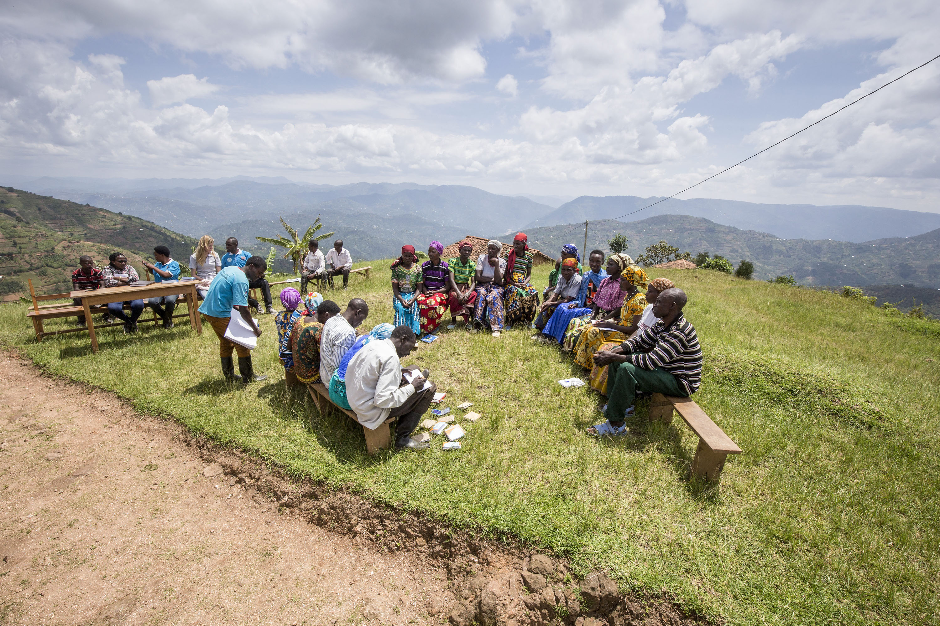

This online call for submissions is being organized jointly by the Office of SDGs, the Food Systems and Food Safety Division, the Governance and Policy Support Unit, and the Development Law Service, to engage various stakeholders and gather **examples of governance-related measures and interventions with transformative impact** **for agrifood systems**.

The results emerging from the received submissions will contribute to informing FAO’s work at country level related to policy, law, and governance for more inclusive, resilient, equitable and sustainable agrifood systems.

To take part in this Call for submissions, please [register](https://www.fao.org/fsnforum/user/register) to the FSN Forum, if you are not yet a member, or “sign in” to your account. Please download the submission template in any of six UN languages (English, French, Spanish, Russian, Arabic and Chinese) and upload the completed form (in Word document format) in the box “Post your contribution” on the call [webpage](https://www.fao.org/fsnforum/call-submissions/addressing-governance-agrifood-systems-transformation).Please keep the length of submissions limited to 2,000 words and feel also free to attach relevant supporting materials**.**

Forany technical questions or assistance please contact [fsn-moderator@fao.org](mailto:fsn-moderator@fao.org).

**The Call for Submissions is open until 18 March 2024.**

**Template for submissions**

*Please note that “transformative impact” refers to innovative, pro-active changes away from “business as usual”*

1. **Proponent (name/institution/unit)**
2. **Title of the example presented and the type of *governance-related* transformative intervention/measure (policy, legal, institutional, financial…)**
3. **Location of the transformative intervention/measure (global/regional/national/sub-national; urban/rural)**
4. **Which aspect, problem or challenge of the agrifood system was the transformative intervention/measure aiming to address?**
5. **What transformational impact was the intervention/measure aiming to achieve (including in terms of the three pillars of sustainability)?**
6. **What was the impact achieved in practice?**
7. **How was the transformative change obtained by the intervention/measure? (a) data and evidence collected, b) concrete ways to measure, c) actors involved)**
8. **What were the key challenges and trade-offs identified and how did a measure/intervention succeed in producing co-benefits and synergies [delivering on economic, environmental and social (including gender equality) sustainability] rather than favoring one option over the other?**
9. **Who were the key actors and stakeholders involved in the design and implementation of the intervention/measures in question, and what were their respective roles and capacities to exert power and influence?**
10. **Did any of these key actors and stakeholders oppose or resist the envisioned transformative intervention, and if so, what were their main motivations and interests, and how was this resistance addressed?**
11. **To what extent is this measure transformative in improving the livelihoods of the most disadvantaged, and how does it contribute to a more inclusive food system?**
12. **What means were used to demonstrate positive changes in the most disadvantaged sectors of the population, and what monitoring and accountability mechanisms were put in place to ensure proper implementation?**
13. **Key lessons that can be learned from your case (both positive and negative) and whether these could be applicable in other contexts with similar characteristics**
14. **Based on your experience, what gaps/areas of improvement still remain that need further action?**
15. **What are your key messages/takeaways from this intervention/measure?**
16. **Please feel free to share relevant links to resources and documentation regarding your intervention.**